Havana, April 15th, 2018.

Journal of the Mexican Chemical Society
Editor in Chief

Dear Prof. Ignacio Gonzalez Martinez,

I am sending my manuscript “GC/MS analysis and bioactive properties of extracts obtained from Clusia minor L. leaves” for submission to your prestigious journal as Full Article, authored by:

Raisa Mangas Marín, Rodny Montes de Oca Porto, Elisabeth Herrera Paredes, Adonis Bello Alarcón, Ivones Hernández Balmaseda, Roberto Menéndez Soto del Valle, Miriam Teresa Paz Lopes, Idania Rodeiro Guerra.

Some species of genus Clusia are used by traditional medicine to treat many disorders including pain, inflammatory diseases, ulcers and wounds. The studies of the specie C. minor L. are few and carried out on botanical aspects. The present study is de first evidence that support the correlation between chemical composition of this specie with antioxidant and anti-inflammatory properties. Our results revealed this specie may be a good potential source of new bioactive agents for developing medicinal or nutraceutical agents.

The results have not been published; it is not under consideration for publication elsewhere. This submission for publication has been approved by all of the authors and by the institutions where the work was carried out.

The authors declare that there are no conflicts of interest.

List of potential reviewers:

1- PhD. Osmany Cuesta Rubio.
2- PhD. Mercedes Campo Fernández.
3- PhD. Luca Rastrelli.
4- PhD. David Marrero Delange.

Thanks you for your attention,

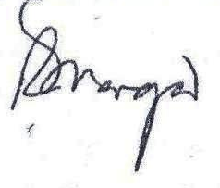
Raisa Mangas Marín, MSc.
Food and Pharmacy Institute,
University of Havana,
Havana, Cuba
raisamm80@gmail.com

