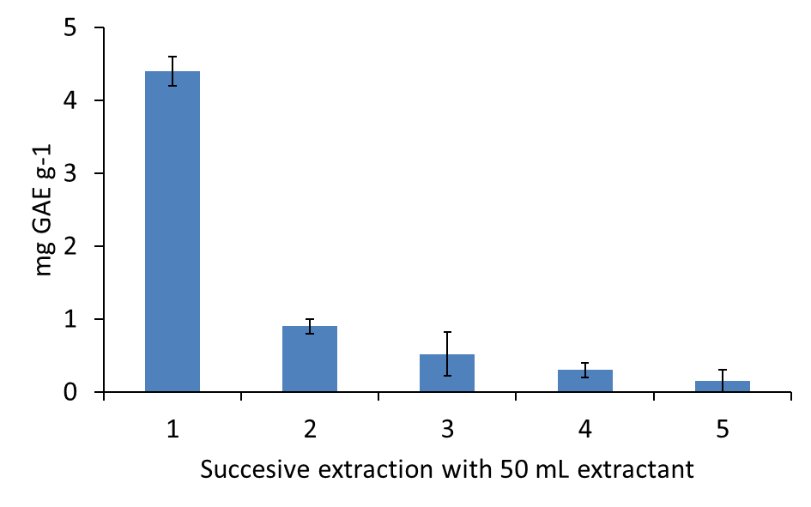

A – Bean 1 (6.5 mg GAE g-1)

Figure 4

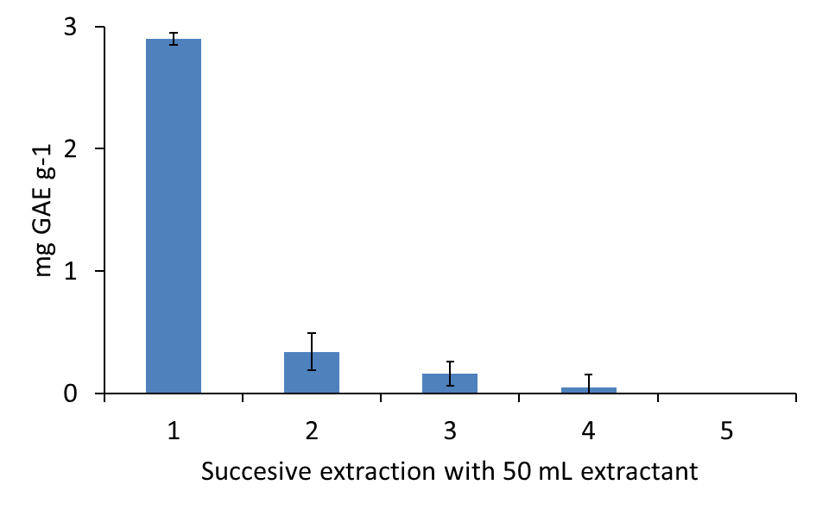

B – Chickpea 1 (3.4 mg GAE g-1)

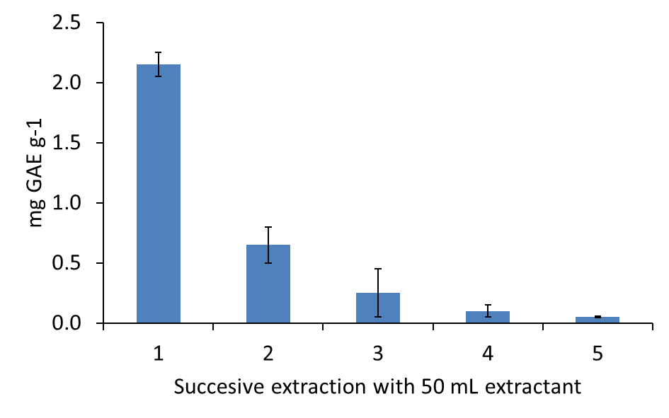

C – Shorgum 1 (3.3 mg GAE g-1)