Dear Prof. Adriana Vázquez A.,
The Editorial Assistance of J. Mex. Chem. Soc.,

I wish to submit a new manuscript entitled “One-pot, three-component synthesis of pyrrolo[2,3-d]pyrimidine derivatives ” by Ramin Javahershenas and Jabbar Khalafy as a research article for consideration and possible publication in J. Mex. Chem. Soc. I confirm that this work is original and has not been published elsewhere nor is currently under consideration for publication elsewhere.
In this paper, we have reported a new synthesis of pyrrolo[2,3-d]pyrimidine derivatives by a one-pot, three components reactions. It is significant that the protocol has the main advantages of short reaction time, green procedure and mild reaction conditions.
The paper should be of interest to readers in the areas of Heterocyclic Compounds in Organic Chemistry, we believe that this paper could possibly fit the criteria of your Journal.
We declare that there are no conflicts of interest.
Four potential reviewers suggested are listed below:
1. Prof. R. H. Prager, Faculty of Science & Engineering, School of Chemical & Physical Sciences, Flinders University, Australia.
He is a well-known in heterocyclic chemistry.
E-mail: rolf.prager@flinders.edu.au
2. Prof. J.A. Joule, Chemistry, the University of Manchester, U.K.
He is the lord of heterocyclic chemistry.
E-mail: John.Joule@manchester.ac.uk
3. C. Williams, Queensland University, Australia.
He is expert in synthesis and isolation of complex natural products, method development, medicinal and physical organic chemistry.
E-mail: c.williams3@uq.edu.au
4. Prof. S. Ballalie, Chemistry, K.N. Toosi University of Technology

, Iran.
He is well-known in multicomponent reactions.
E-mail: balalaie@kntu.ac.ir
I would be much grateful if you could kindly provide the necessary arrangements for evaluation of manuscript.
Please let me know if any further action was necessary.
I look forward to hearing from you in due course.
Thank you for your consideration of this manuscript.
With Best wishes
Sincerely Yours,
Jabbar Khalafy* Ramin Javahershenas
E-mail: jkhalfi@yahoo.com E-mail: jshbco@yahoo.com

Signature Signature
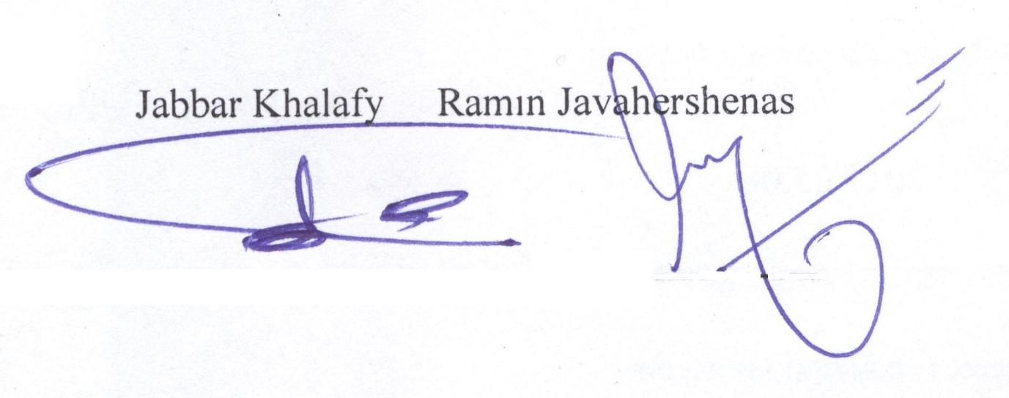

Department of Organic Chemistry, Faculty of Chemistry, Urmia University, Urmia, Iran.

Tel/Fax: +98-44-3275-5294.

* Corresponding author’s e-mail:jkhalafi@yahoo.com; j.khalafi@urmia.ac.ir

