March 23, 2018
Prof. Dr. Ignacio González Martínez,
Editor-in-chief
Journal of the Mexican Chemical Society

Dear Prof. González-Martínez
I am sending herewith a manuscript entitled:
“Design, synthesis and biological evaluation of novel fungicides for the management of Fusarium DieBack disease”
by José Luis Olivares-Romero, et. al., which I should like to submit for publication as research article in Journal of the Mexican Chemical Society.

The increasing incidences of invasive fungal infections are having a significant impact on a wide range of crops of economic importance, which generate economic losses worldwide each year. For instance, Fusarium Dieback, a new and lethal insect-vectored disease can host over 300 tree species including the avocado trees. This problem has recently attracted the attention of synthetic chemist in order to develop new triazol antifungal agents. On the other hand, due to severe drug resistance to “classic” triazol antifungal agents, in this work a series of novel antifungal triazoles with a p-trifluoromethylphenyl moiety were designed, synthesized and characterized by Nuclear Magnetic Resonance ¹H, ¹³C and DEPTQ 135 spectroscopy, and HRMS-QTOF. Most of the target compounds synthesized showed from modest to good inhibitory activity in comparison with the commercially available propiconazol; in particular, compounds 7 and 13 were active at 1mM against Fusarium solani and at 100 μM against Fusarium euwallaceae.
Our new molecules have one major scientific breakthroughs: To the best of our knowledge, this is the first preliminary report dealing with the extremely phytopathogenic fungus Fusarium euwallaceae which is responsible of the disease Fusarium Dieback through the use of some novel and quiral triazol derivatives that contains a para-trifluoromethyl moiety. Our molecules exhibited good antigungal activity and low phytotoxicity when compared to the commercially available propiconazol.
Therefore, this report will encourage the development of other chiral and novel molecules to be used as fungicides against Fusarium Dieback. A wide audience of scientists interested in synthesis, bioorganic and agricultural chemistry and other areas of science will appreciate our results. We believe that this manuscript is appropriate for publication in The Journal of the Mexican Chemical Society.

Suggested suitable reviewers for our communication:

Francisco Yuste López UNAM yustef@unam.mx
Marcos Hernandez UNAM marcoshr@unam.mx
Teresa Mancilla CINVESTAV tmancill@cinvestav.mx
David Cruz Cruz Universidad de Guanajuato cruz.david.c@gmail.com
Ignacio Regla Contreras UNAM regla@unam.mx

Thank you for considering this manuscript. We look forward to your response.

Sincerely,

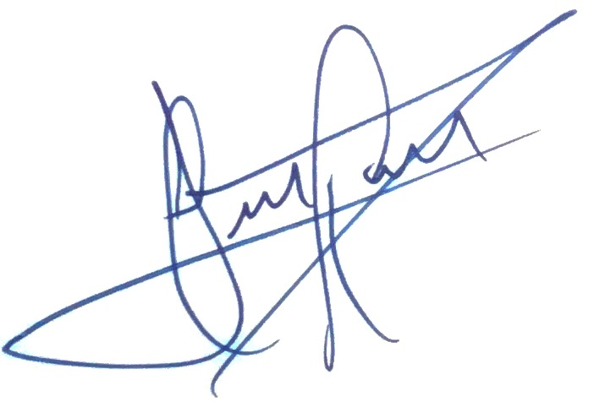
José Luis Olivares-Romero, Ph. D.

